AWS IAM PROJECT

1. Project Overview
This project demonstrates how to create and manage AWS IAM users and user groups, assign permissions through groups or IAM policies, review the configuration, and verify the completed IAM setup using the AWS Management Console.

Project Objectives
- Open the AWS IAM Users section.
- Create an IAM user through the Create user wizard.
- Configure console access for the IAM user.
- Configure permissions using IAM user groups and policies.
- Review and create the IAM user securely.
- Retrieve the sign-in information shown after successful creation.
- Open IAM User Groups and create a user group.
- Verify users, groups, and permissions after completion.

Tools / AWS Services Used
- AWS Identity and Access Management (IAM)
- AWS Management Console
- IAM Users
- IAM User Groups
- IAM Policies

Step 1 — Open IAM Users
Open the AWS Management Console and go to Identity and Access Management (IAM). Select IAM users. This page is used to create and manage IAM identities.
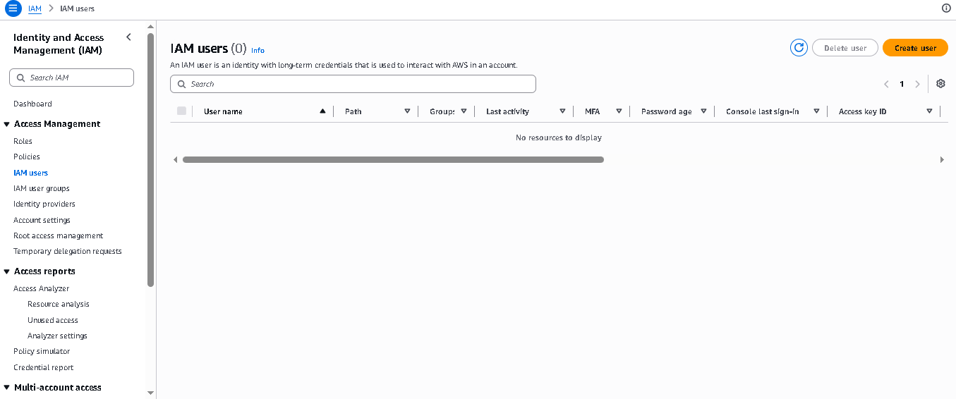
Action: Click “Create user” to start creating the new IAM user.

Step 2 — Specify the IAM User
In the Create user wizard, enter the required user name. The reference shows the user-details and console-access area.
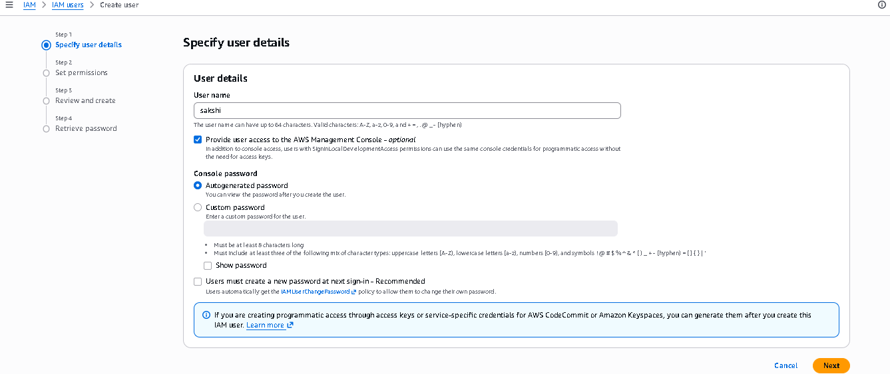
Action: Enter the username carefully and continue to the permissions step.

Step 3 — Configure Console Access
Configure the AWS Management Console access option shown in the reference. This section controls whether the IAM user can sign in to the AWS console.
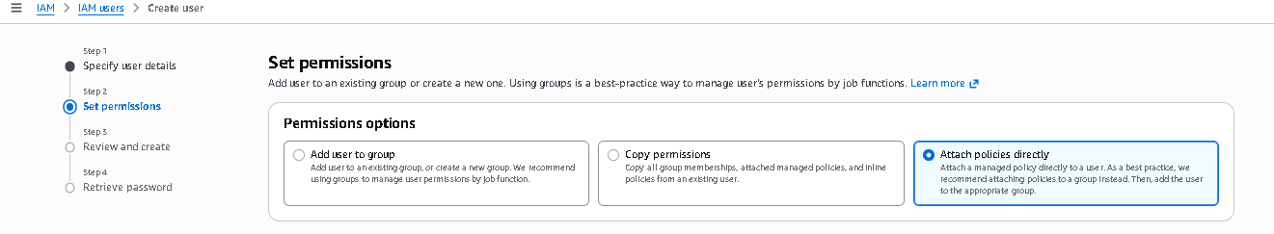
Action: Select the console-access option required for the practical and configure the password settings shown by AWS.

Step 4 — Set Permissions
On the Set permissions page, choose how permissions will be assigned. The reference shows options for adding the user to a group, copying permissions, or attaching policies directly.
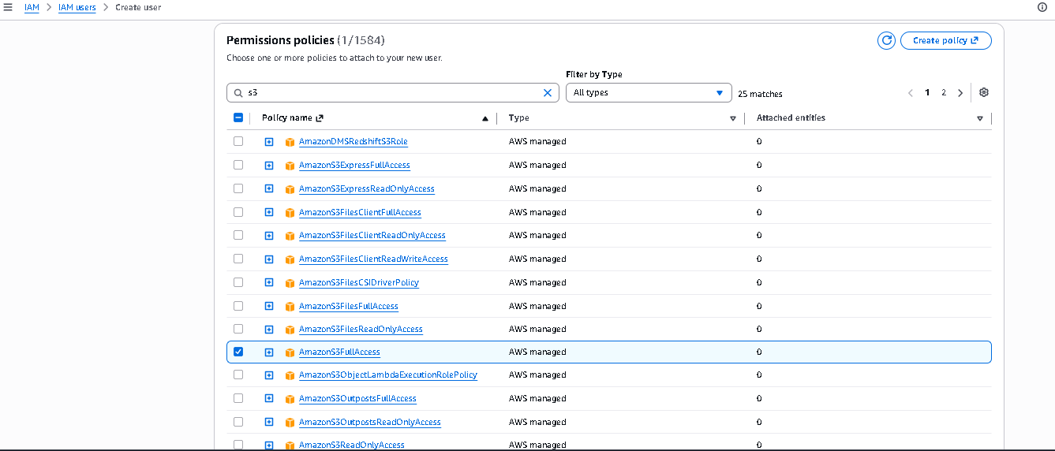
Action: For a Users & Groups project, use the group-based option when permissions are intended to be managed through an IAM group.

Step 5 — Select / Review Policies
The reference shows the available IAM policies and their policy information. Policies define what actions the user or group is allowed to perform.
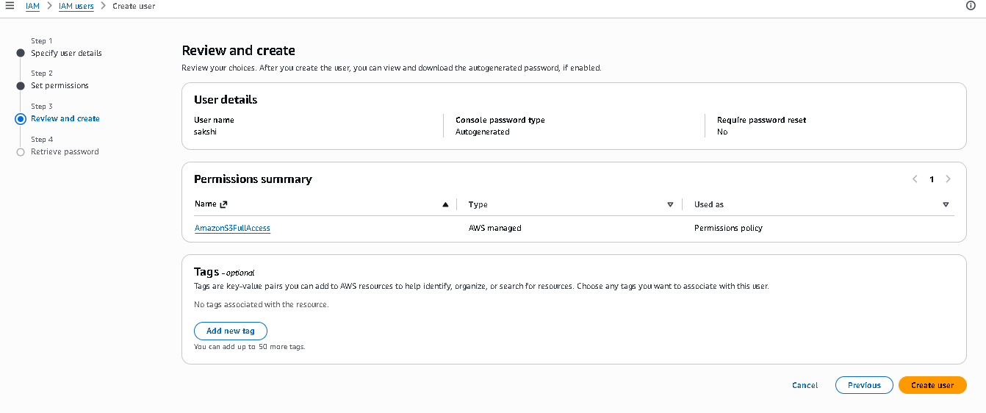
Action: Search for and select only the policy required for the practical. Avoid unnecessary permissions.

Step 6 — Review and Create
Review the IAM username, access configuration, and permissions summary before creating the user.
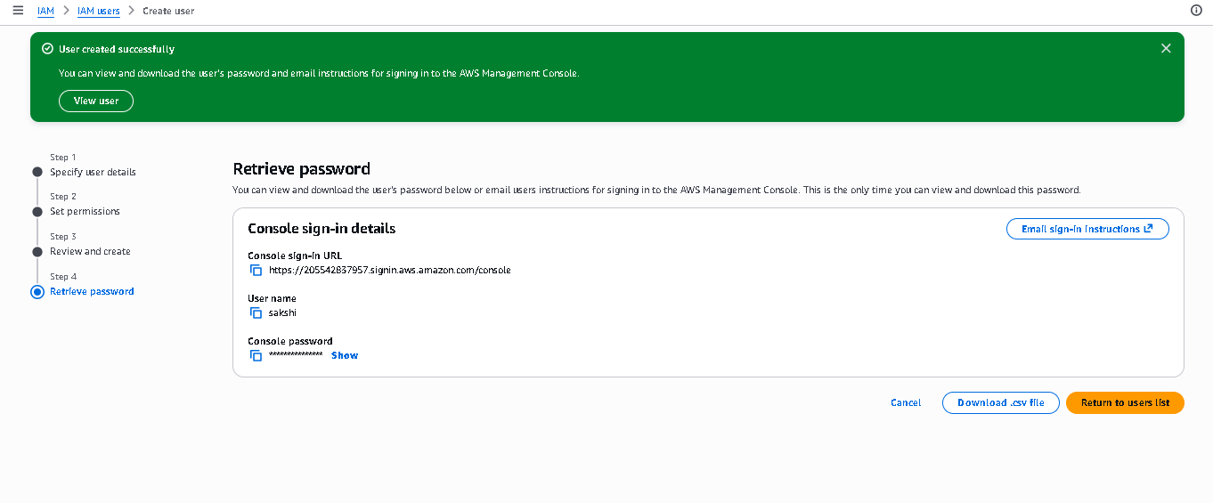
Action: Check all details carefully and click “Create user” when the configuration is correct.

Step 7 — User Created Successfully
AWS displays a successful user-created page. The reference shows the console sign-in information and generated password retrieval area.
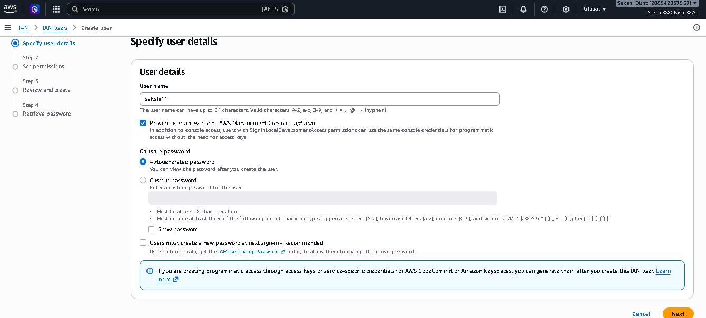
Action: Save the required sign-in information securely. Do not publish real credentials in the project report.

Step 8 — IAM User Sign-In
Open the IAM user sign-in page and enter the AWS account ID or alias, IAM username, and password.
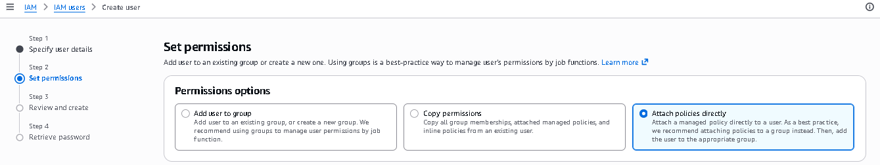
Action: Use the newly created IAM user for normal project work instead of using the AWS root account.

Step 9 — Open IAM User Groups
Return to IAM and select User groups from the left navigation. This section is used to manage groups of IAM users.
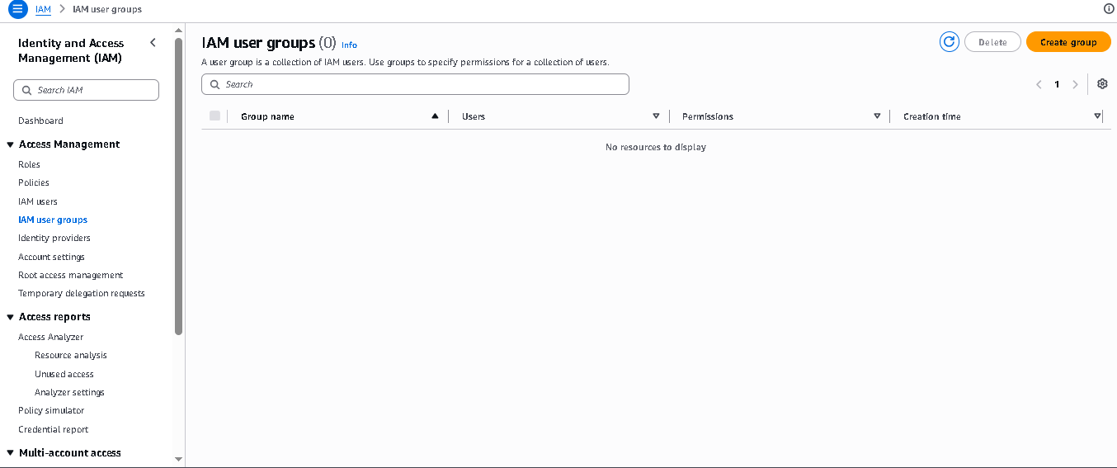
Action: Open the User Groups page and choose the option to create a new group.

Step 10 — Start Creating the User Group
The Create user group workflow is displayed. The group is used to organize users who need similar permissions.
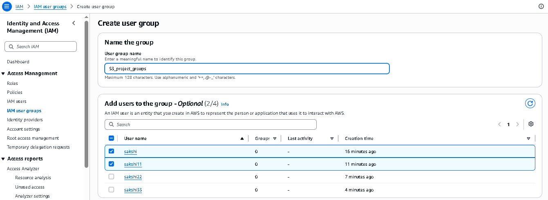
Action: Click “Create user group” and enter a meaningful group name.

Step 11 — Enter Group Details
Enter the required group name and review the available user/policy configuration areas shown in the reference.
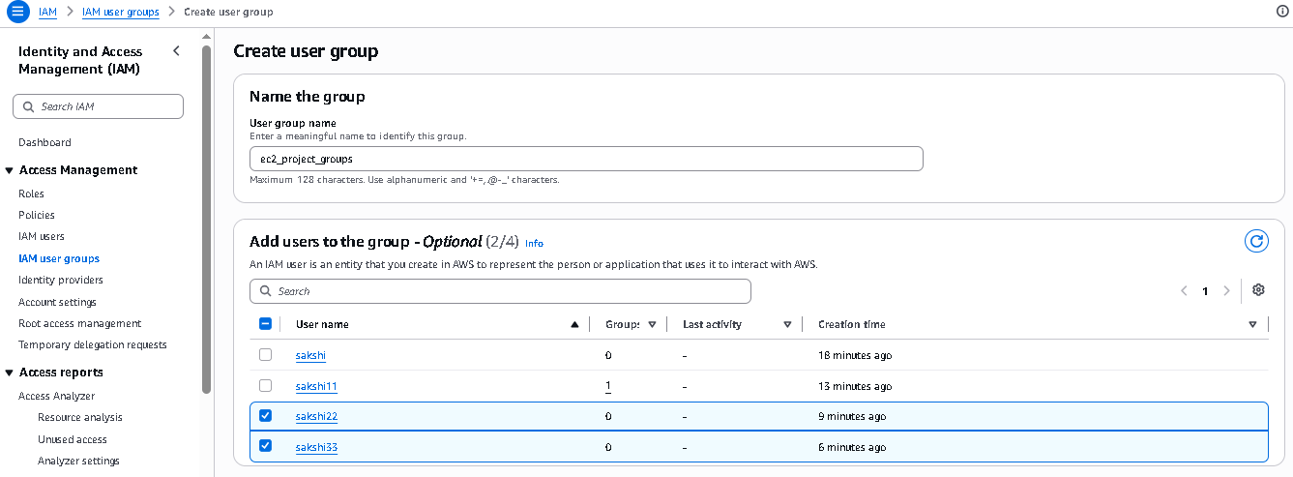
Action: Use a clear group name based on the job function or project requirement.

Step 12 — Configure Group Permissions / Members
Configure the group with the required users and permissions. Group-based permissions make it easier to manage access for users with similar requirements.
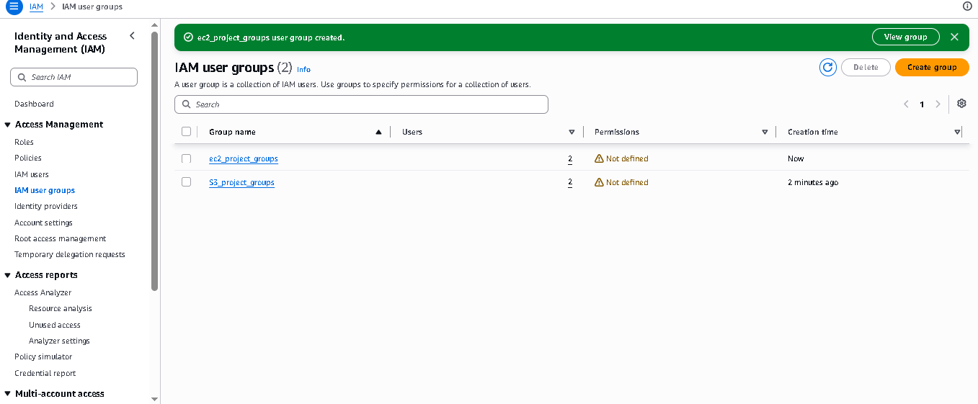
Action: Select the required users and permissions, then review the configuration before creating the group.

Additional Reference Screenshots
The supplied Users & Groups reference contains additional screens from repeated user-creation and permission workflows. They are included below so the project remains aligned with the source file.
Additional user-details screen.
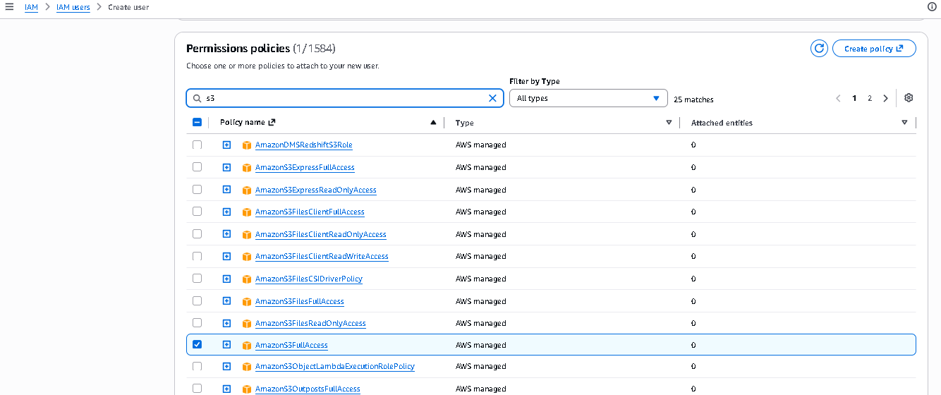
Additional Set permissions screen.
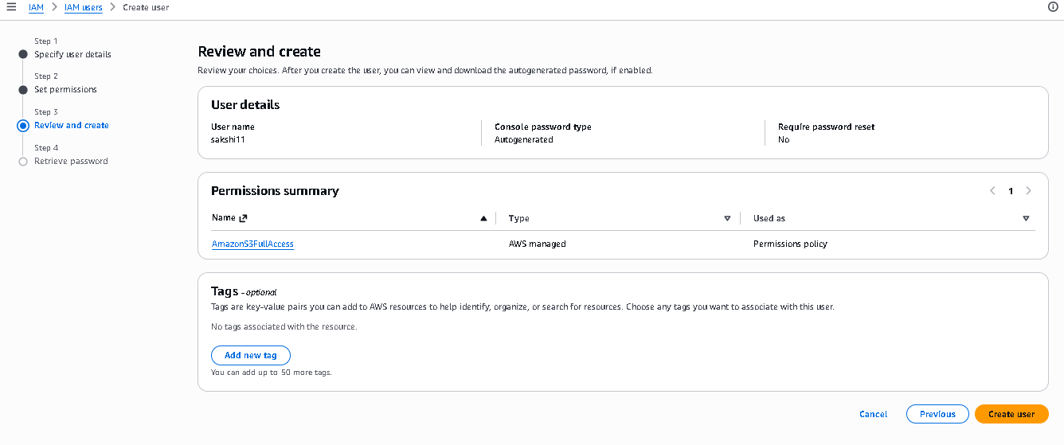
Additional successful user-creation / sign-in information screen.
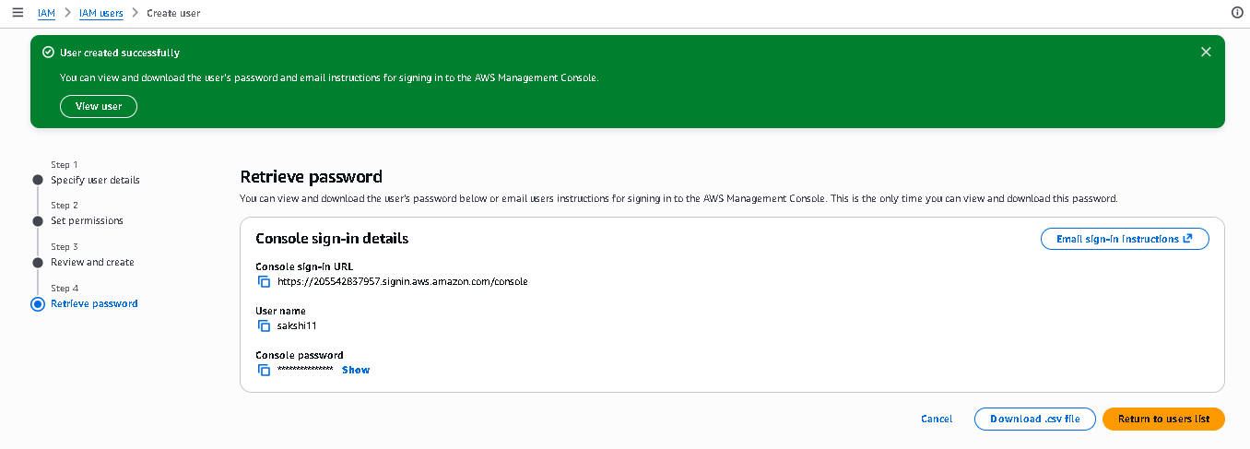
Additional Specify user details screen.
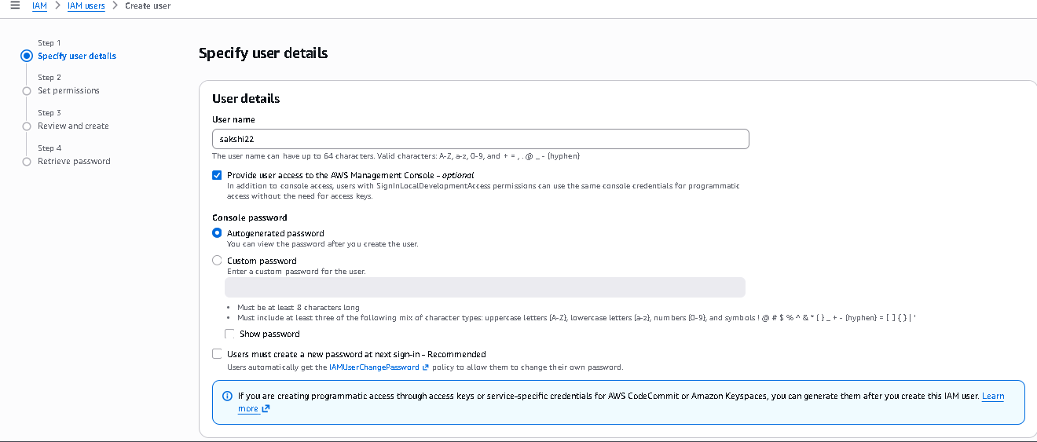
Additional Set permissions screen.
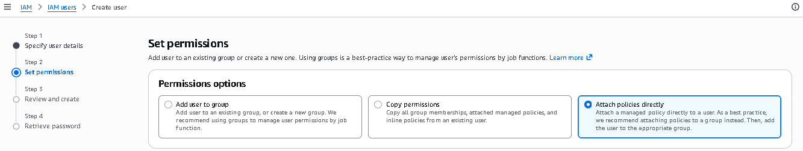
Additional IAM policy selection screen.
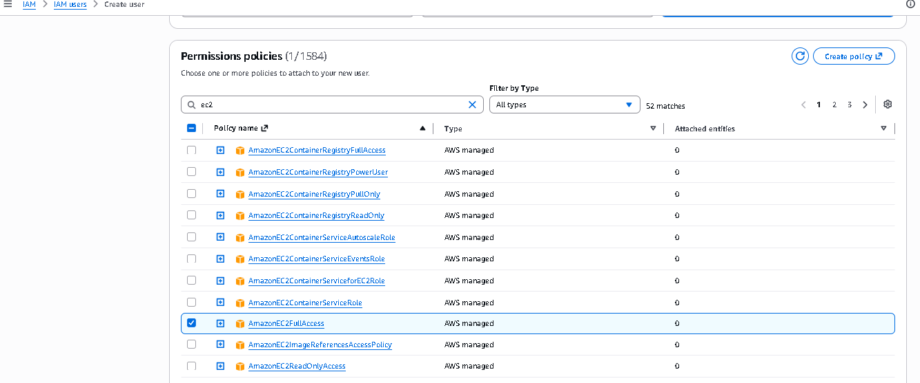
Additional Review and create screen.
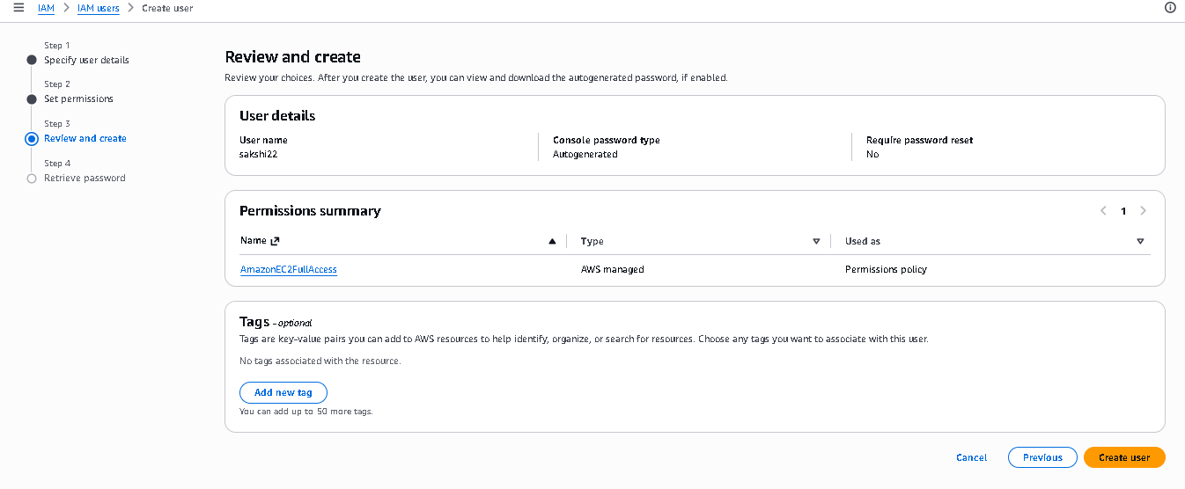
Additional successful user-creation screen.
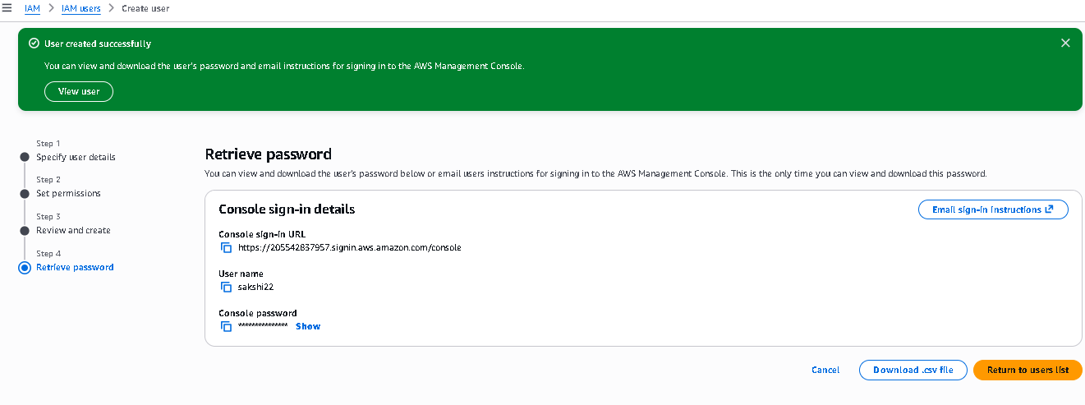
Additional Specify user details screen.
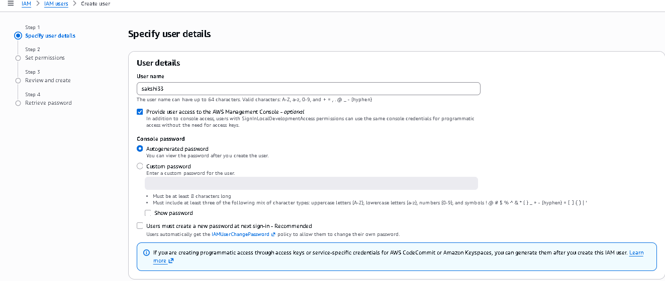
Additional Set permissions screen.
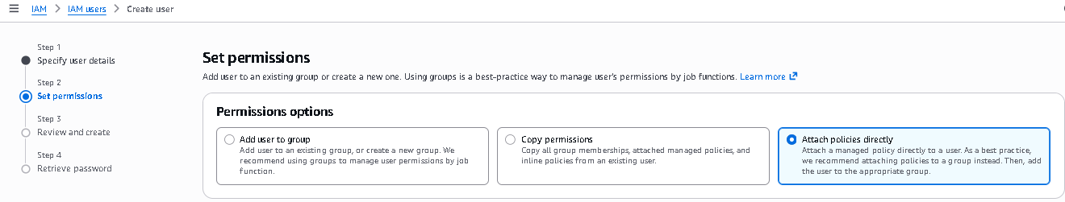
Additional IAM policy selection screen.
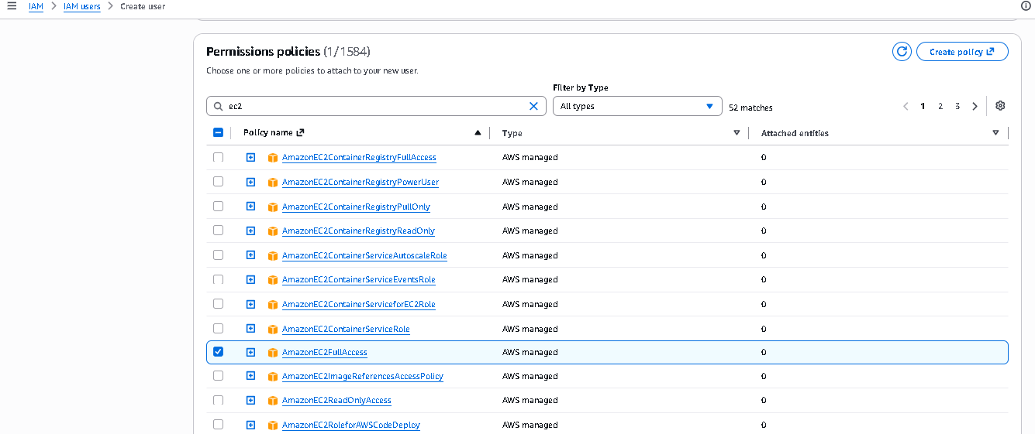
Additional Review and create screen.
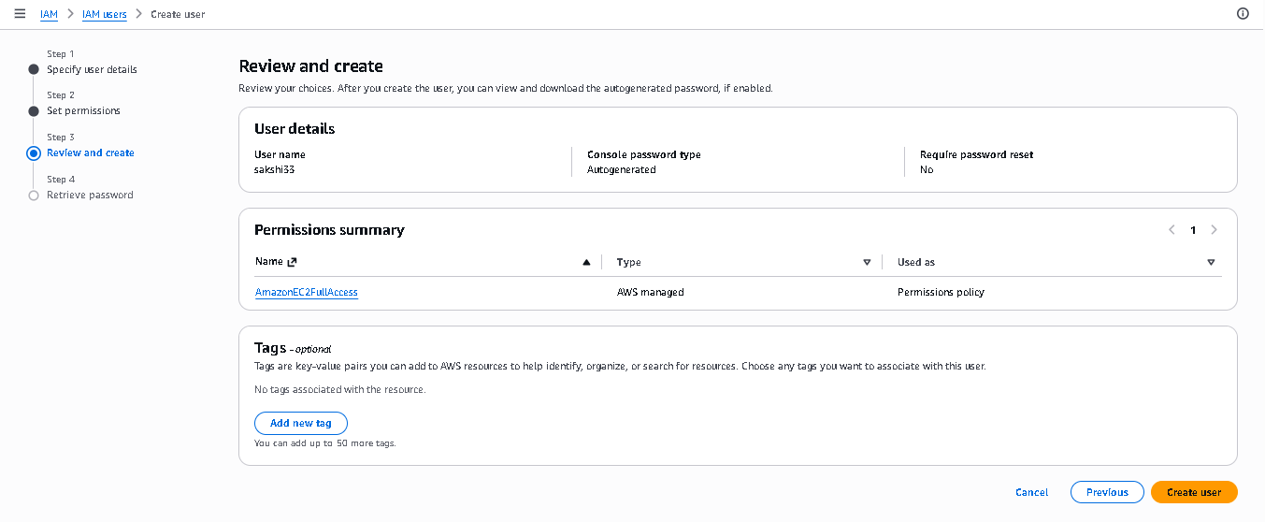
Additional successful user-creation screen.
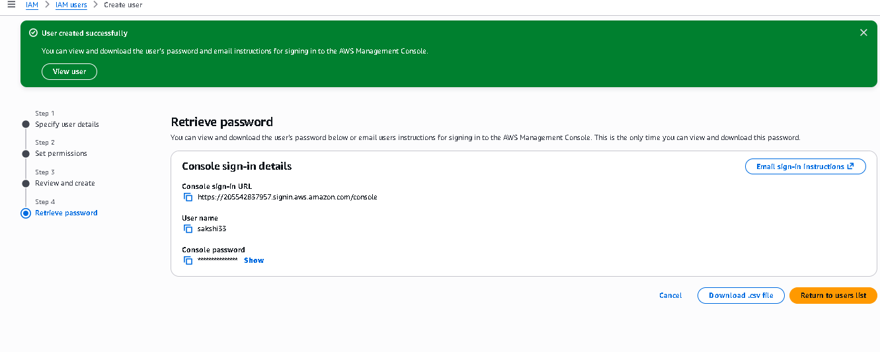
IAM Users list / verification screen.
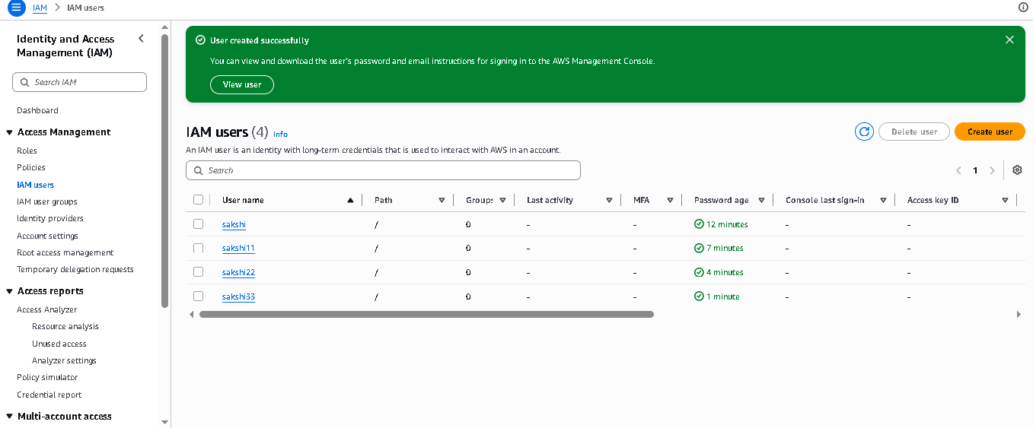

2. Project Result
The practical workflow is completed when the IAM user is created successfully, the required permissions are configured, the user can sign in to the AWS Management Console, and the required IAM user group is created and configured.

3. Security Points
- Avoid using the AWS root account for routine work.
- Use IAM users, groups, or roles with only the permissions required.
- Prefer group-based permission management when multiple users have the same access requirements.
- Use strong passwords and MFA where possible.
- Do not share IAM passwords, access keys, or other credentials.
- Review and remove unused permissions regularly.

4. Conclusion
This project demonstrates a basic AWS Identity and Access Management workflow focused on IAM users and user groups. An IAM user was created, console access and permissions were configured, the user-creation process was reviewed, and the IAM User Groups section was used to create and manage a group. The screenshots provide visual evidence of the practical workflow.

5. Reference
The structure and presentation of this document follow the uploaded “IAM_Project.docx” reference, while the step content and screenshots are based on the supplied IAM Users & Groups project material.

